KAMLOOPS MINOR LACROSSE ASSOCIATION

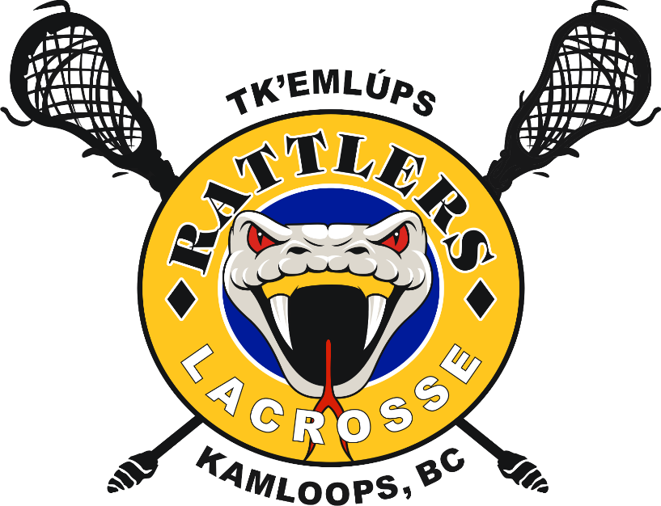

MANAGER'S MANUAL
BOX LACROSSE

Revised February 2023

TABLE OF CONTENTS…… 2
Introduction 3
Team Manager Duties 4
Equipment Shorts & Jerseys 5
Tournaments 6
Team Volunteers 7-9
Team Fees 10
Game Sheet Procedures 11
Temporary Player Call-Up 12
Game Rescheduling 13
Photo Day 14
KMLA Involvement 15
Documents 16
Player Medical Form 17-18
Code of Conduct Form 19
Code of Conduct for Players 20
Risk and Safety Guidelines 21-25
Game Sheet Procedures 26
Commissioner Contact Info …………………………………………………………………..27

INTRODUCTION
Welcome to Kamloops Minor Lacrosse and thank you for your commitment to making this year's lacrosse season a success.

If you are a new team manager, we hope that this manual will help guide you through the season and explain what is required of you. To those returning managers, thank you for your continued support and we hope that this manual will also assist you with any questions that may come up. If you have any suggestions of things to add to the manual in the future, please contact the executive.

If you have any questions during the season that are not answered in this manual, please feel free to contact the KMLA Executive and Board (contact information is on the KMLA website www.kamloopsrattlers.com)

OUR MISSION

KMLA is a “Club” focussed on turning Youth Athletes into “Champions” in sport and in life through recreational and competitive Box and Field Lacrosse. The Association dedicates itself to the promotion of positive lacrosse experiences for all members through supportive coaching, leadership and mentoring. Strict adherence to the core values of the Association as defined by the acronym REALM (Respect, Effort, Awareness, Learning, and Mistake Management) guide our culture and are demonstrated in the delivery of our Lacrosse program. Additionally, the Association strives to ensure that at all times the membership (coaches, players, and parents) adheres to codes of fair play, sportsmanship, equality and non-discrimination, with the goal being to foster and develop the qualities that define character and provide skills (leadership, initiative, responsibility and empathy) that reach beyond the confines of the athletic arena

Have a great season!

KMLA Executive

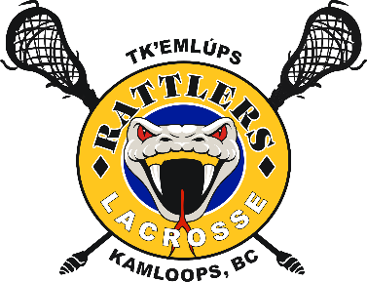

TEAM MANAGER DUTIES

It is the team manager's responsibility to complete or delegate all of the items listed in this manual.

The main responsibility of the team manager is communication. Teams will be given TeamSnap account as KMLA now uses TeamSnap Clubs and Leagues to ensure good communication. You will need to regularly pass on information to the team from the association and the coach. You can communicate with the team and coaches using the TeamSnap email option as well as the group or individual chats.

You will be assigned your team roster from KMLA via TeamSnap. Parents of players will have also been “invited” to your team via TeamSnap and you will want to encourage them to take the time to add/ update parent info to each player. You will need to add the jersey numbers to this list once they have been assigned.
As soon as possible, you should contact all players by email to send out some initial information for the season using the TeamSnap App. All communications should be done within TeamSnap

As soon as the schedules are available, they can be uploaded to TeamSnap.

The manager and coaches should have a parent meeting at the beginning of the season. Coaches normally discuss their expectations for the season and items such as player and parent conduct, team duties Including Jersey Person, Game duties, game results submission and team budget.

EQUIPMENT, SHORTS & JERSEYS

Each player is required to have their own playing equipment. If there are any questions as to what is required, there is a list of the equipment on the KMLA Website that parents can be directed to.

https://www.kamloopsrattlers.com/clubs/2648/pages/75472

Coaches will be contacted to receive their equipment, including goalie gear.

League shorts will be supplied by the association and the cost for the shorts is included
in the season fees. The shorts are the player's own shorts and are not to be collected at the
end of the season

TOURNAMENTS

You should discuss tournaments with the coach as soon as possible. Tournaments generally fill up quickly so you want to ensure that the kids get the opportunity to attend.

Tournament fees generally range from $500 - $800 per team. All costs to enter
tournaments are the responsibility of the team. This is discussed more in the team fees section.

- A tournament schedule will be provided by BCLA (it can be found on BCLA's web site: (www .bclacrosse.com). This is usually posted early March and does not leave much time for decision making, please ensure this is your first priority.
- Consult with the Coach(s), parents and players as to how many tournaments they would like to enter (remember your team may have zone championships and/or provincials also and they may occur out of town).
- Register for tournaments as soon as you possibly can, they fill up very quickly.
- Tournaments will be booked before league game scheduling can be completed. The scheduler will be required to provide those tournament black-out dates on
your team’s behalf during scheduling meetings. Please contact the KMLA scheduler if you have any questions (see KMLA website for name and contact
info)
- Teams are responsible for funding their own tournament entry fees, travel/hotel costs, etc. If you have a non-parent coach, the team will be responsible for paying for their hotel

You (or another designate) should also look into accommodations when out of town. Quite often the host association will make arrangements with hotels/motels in their area to provide reasonable rates for traveling teams. This information would be included in their tournament information package. It is still up to you (or someone designated) to reserve a block of rooms for the team so the players can be all together.

Once at the tournament, it is usually the Manager's duty to check the team in with the tournament co-coordinators, you will have likely received your game schedule ahead of time by email so you will know when your first game is scheduled. You will likely have to fill out the roster on the game sheets for each game.

Please note that if your team is attending a tournament out of province, you must submit an Out of Province/ Out of Country Travel Permit From to the BCLA. The form is found on the BCLA website under Box Lacrosse, Forms, Minor Box.

TEAM VOLUNTEERS
At the beginning of the season, you should be assigning/asking for volunteers for the following duties. In the event that games are permitted, these volunteers should be familiar with the roles:

  - Home game duties – game sheet, and score clock. 30 second shot clock will be provided by the officials. There is an online tutorial on the BCLA website under the Volunteers tab, share this with your parents to ensure your game sheet is completed correctly.
  - Safety Personnel – The BC Lacrosse Association's General Operating Policy, Section 16.04 states 'All Teams must have a designated person responsible for initial concussion/head injury assessments during all practices and games. In addition *to having taken a first aid training course, this designated person must have completed a concussion management course and be capable of making an assessment of a concussion/head injury at the time of an incident. (*does not have to be the same individual). Team Manager’s will be responsible for ensuring that a Safety Person(s) trained with these qualifications is present at each lacrosse event. KMLA will provide funding for First Aid Training to those designated individuals and resources for Mandatory Concussion Training. It is suggested that each team have up to 3 trained personnel to ensure coverage at all events.

  - Jersey parent - it is required that all jerseys are collected after each game

  - Game sheet duties -TOMBLC requires the Coach or Manager of the Home team to email a copy of the game sheet within 24 hours to: gamesheets@tomblc.com and Division Commissioner. TOMBLC Commission has the discretion to deduct 2 points for teams who do not email game sheets within 24 hours of the completion of a game. White Paper copies must be physically mailed to Commissioner no less frequently than once per week and received by the Division Commissioner within 10 days. Please refer to the TOMBLC Website for further information at http://tomblc.com/docs/TOMBLC-GameSheetProcedures_2022.pdf.

  - Media reports – All media reports, including social media must go to Courtney Bissell at socialmedia@kamloopsrattlers.com.

- Home game duties
A rotation schedule should be set up for the home game duties. When scheduling, do not schedule the manager's or coach's family as they have taken on large volunteer roles already. Rotation should be done alphabetically and just rotate through the team until all dates are full.
If a family is unable to fulfill their position at a specific game, it is their responsibility to trade with someone else on the team to ensure that all positions are covered for all home games. Please make sure you emphasize this on your email to parents regarding duties.

Game sheet
Please see Appendix A - Game Sheets for instructions on how to complete the game sheet. Please feel free to send these pages to any parents who have not done the game sheet before and require some instruction.

Score clock
Every arena's score clock is slightly different. There will be printed instructions in the score clock booth at the arenas to show how to operate.

Game lengths are as follows:

U7 (Mini-Tyke) - two training sessions of 15 minutes in length and two games of 15 minutes in length. Each player, with the exception of the goalkeeper, plays a 3 minute shift. No 30 second shot clock

U9 (Tyke) - two training sessions of 15 minutes in length and two games of 15 minutes in length. Each player, with the exception of the goalkeeper, plays a 3 minute shift. No 30 second shot clock.

U11 (Novice) – three 15 minute periods, running time periods and 3 minutes between periods. No 30 second shot clock.

U13 (Pee Wee), U15 (Bantam), and U17 - three 20 minute, stop time periods, change on the fly, 30 second clock and 10 minutes between periods.

- Safety Personnel –The BC Lacrosse Association's General Operating Policy, Section 16.04 states 'All Teams must have a designated person responsible for initial concussion/head injury assessments during all practices and games. In addition *to having taken a first aid training course, this designated person must have completed a concussion management course and be capable of making an assessment of a concussion/head injury at the time of an incident. (*does not have to be the same individual). Team Manager’s will be responsible for ensuring that a Safety Person(s) trained with these qualifications is present at each lacrosse event. KMLA will provide funding for First Aid Training to those designated individuals and resources for Mandatory Concussion Training. It is suggested that each team have up to 3 trained personnel to ensure coverage at all event

- 4. Jersey Parent
Each team normally has one family responsible for the jerseys. At the end of each game, this parent collects the jerseys and washes them before the next game. Jerseys must be washed in cold water and hung to dry.

5. Game Sheets
Game sheets must be sent to Division Commissioners and Zone Director after games (See Game Sheet Procedures). It is a good idea to have the media relations parent also responsible for collecting and sending out the game sheets to the appropriate people as they will need the game sheet for the stats.
The local media support minor sports and will publish scores and other game information

6. Media reports – All media reports, including social media must go to Courtney Bissell at socialmedia@kamloopsrattlers.com.

TEAM FEES

This should be discussed with your coach and parents to find out if they would like to
have team fees for logo gear & wrap up parties.

It is the manager's duty to determine the amount of team fees, collect from parents, and pay for the necessary items. It will be mandatory for the manager to prepare a budget, monitor and manage the team expenditures and ensure that all remaining monies are equally distributed back to the team at the conclusion of the season.

Budgets/financial reports will be submitted to the Manager Coordinator who will ensure that the handling of team fees has been carried out in a responsible manner. Any discrepancies will need to be corrected within 1 week of the season end and managers will be held financially responsible for any delinquent expenses. It must be stressed that budget management and the misappropriation of funds can result in criminal charges, please ensure that team fees are handled appropriately. KMLA will not be responsible for debts owed by individual teams.

Some things that are normally included in team fees:
  - Association logo wear
  - Tournament fees
  - Raffle basket & gift cards (if your team is in the Alan Price or Karsten Huth tournaments – PeeWee, Bantam & U16 team)
  - Some teams will do team meals for tournaments and there will be costs incurred
  - Team wind up
  - Coaches gifts - most teams choose to purchase a small gift for the coaches.

Some teams determine the team fees and everyone pays the full amount. If you have a player that, for instance, cannot make one of the tournaments, you may want to adjust that player's fees accordingly or consider team fundraising to ensure equal opportunity to participate in team events.

If your team participated in a home tournament, the teams receive a portion of the profits from these tournaments. The amount received can vary significantly so it is difficult to account for this in your team budget.

GAME SHEET PROCEDURES

Each home team is required to provide a game sheet. Please be aware that even if you are not playing in your home arena, if your team is listed as the 'home' team on the schedule, you should be prepared to provide a game sheet. The manager will receive enough game sheets at the beginning of the season for all the home games of the season.

It is the responsibility of the manager or other designate to ensure that the game sheet is completed with the game number, division, game date, players and coaches. You may fill out the sheet in advance but remember to cross off any players that are absent for that game. Suspended players/coaches need to be listed on the game sheet with a strike through their name. In the notes, a comment is made referring to which game number the player/coach is sitting (ie. 1 of 2).

When the away team arrives, the home team manager must get the game sheet to the away team manager to be completed and returned so that it can be handed to the referees prior to game time.

Game sheets must be signed as "verified" by the Coach or Team Manager. The referee's in attendance should be clearly marked on the game sheets.

The HOME team is responsible for distributing the completed game sheets as follows:

White copy Division Commissioner
Yellow copy to the losing team
Pink copy to the winning team Goldenrod copy – NOT REQUIRED

Names and contact information for the Division Commissioner are on the TOMBLC website and listed in this booklet.

When your team is the away team, it is your responsibility to enter the roster on the game sheet that the home team has provided. Many teams prefer to print game sheet sticker labels that can be put on quickly. A template for the labels is included in this package. Please remember that each copy of the game sheet requires a label so you will need 4 per game.

TEMPORARY PLAYER CALL-UPS

You are able to call-up players from another KMLA team on a temporary basis, in the event that you have a short roster. Those players called up may only play a maximum of four games. You are encouraged to call-up players from another division when possible. Please read the rules regarding call -ups carefully. If call-ups are not done correctly there can be serious consequences to the players, coaches, teams and managers involved.

If you wish to call up, contact the KMLA Head Coach for the coach or manager's phone numbers for the eligible teams. You must obtain the coach or manager's permission before calling up a player and you must inform the Head Coach of the call up. There are special rules regarding goalies that generally make it easier to call them up. Check with your KMLA Head Coach or League Commissioner.

GAME RESCHEDULING

Game rescheduling will not be allowed. If you have any concerns in regards to this your first point of contact will be our KMLA president.

PHOTO DAY

Photo Day will be May 10^{th,} 2023

Photo day is for the entire KMLA association and requires all teams to be prompt!

Before photo day, you will receive a package with order forms for each player, and a schedule of when your team's photos are. The manager should distribute the forms to the parents shortly before photo day. Each player receives a Memory Mate (one team photo and one individual photo) at no cost. They can order additional prints as well.

You will need to ensure that the jerseys are taken on the photo day, it is best not to rely on the player/parent to remember their jersey. Please have two or three volunteers to help organize your team, this day is very hectic and moves extremely quickly so late players will likely not get a photo opportunity. Most often players will wear their jersey, shorts, socks and shoes as well as their gloves and sticks. Players do not need to come with their helmets or shoulder pads. The exception is the goalie who usually wears all their gear except their helmet.

Players will need to be lined up by jersey number, the forms will be handed in along with the team log and then the players will be called first for their individual photo and then the team photo:

The order forms are limited and extras are not always available. Please stress that your
parents complete the form when you give it to them and you collect them back the same night, often if they go home with the player/parent they get forgotten which significantly delays the timing of the team photo.

When the photos come in you will be notified by the Division Director and an agreed upon pick up location will be organized. Please ensure the photos are quickly distributed to the parents.

KMLA INVOLVEMENT

Please encourage your team's parents to get involved and help out. It may be intimidating at first, especially for parents new to the sport, but it is a great way to learn more about lacrosse and get to know others. Please pass along the following links to your team's parents so they can stay involved and informed.

Kamloops Rattlers Website: http://www.kamloopsrattlers.com

You can also check out the Kamloops Minor Lacrosse Facebook Group here: https://www.facebook.com/kamloopsrattlers.

Annual General Meeting

Please make sure that parents are aware of the Annual General Meeting and encourage
them to attend. Our association is always looking for new people with new ideas. The executive is made up of volunteer parents who care about lacrosse and the children.
They do not have to have experience to get involved. The Annual General Meeting date will be announced towards the end of the season but usually occurs in November.

DOCUMENTS

The below documents should be discussed and shared with all parents, and where applicable team managers/ coaches should collect the forms and keep them on file.

- Medical forms
- Player code of conduct
- Parent code of conduct
- Risk and Safety

All of the above forms will be available to the Coaches and/or Managers within the Coaches/Managers sedition of kamloopsratttlers.com

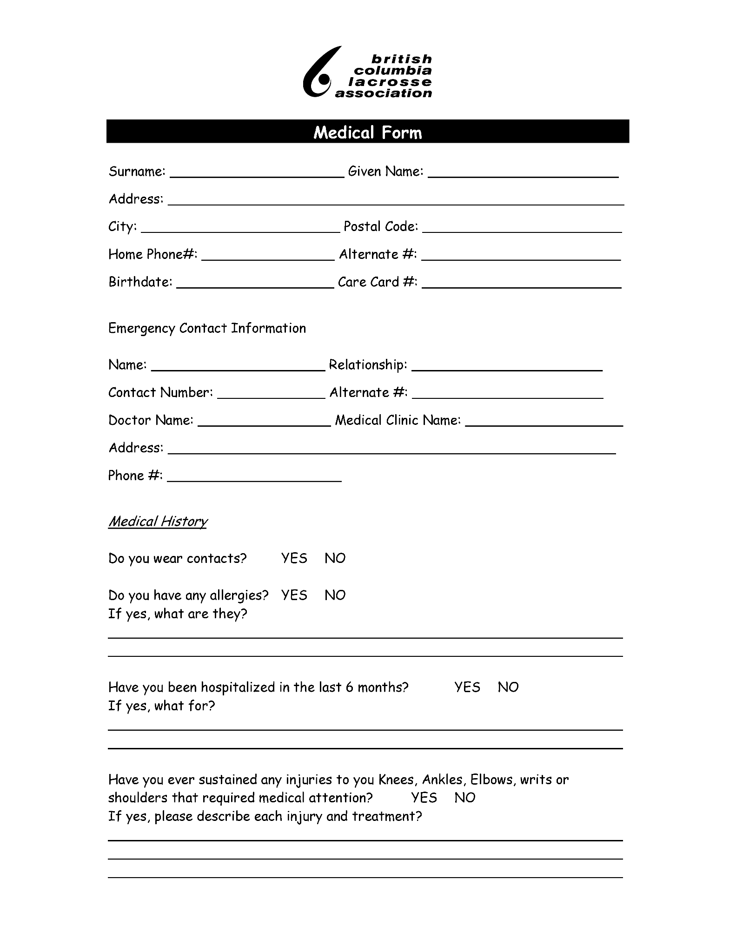
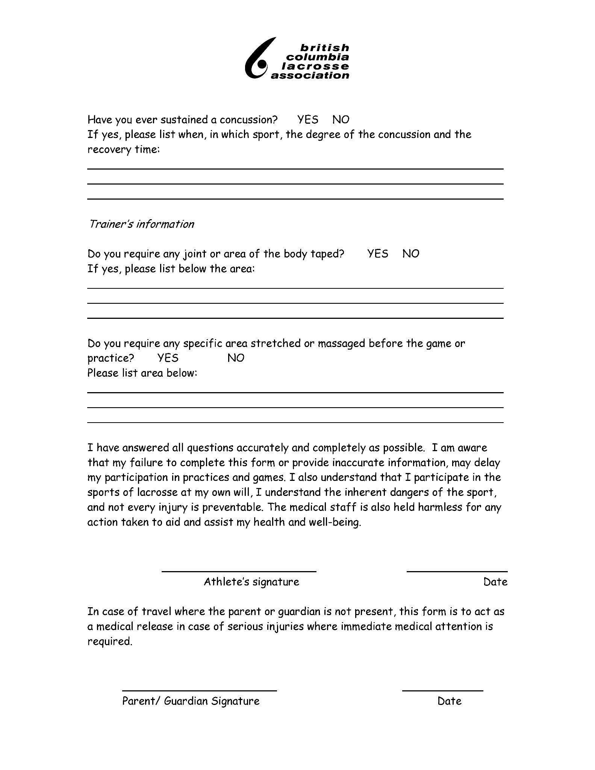

KAMLOOPS MINOR LACROSSE ASSOCIATION

CODE OF CONDUCT AGREEMENT FOR PLAYERS

- I will play lacrosse because I want to, not just because my parent(s) or others want me to.
- I will play by the rules of lacrosse, and in the spirit of the game.
- I will control my temper. I realize that fighting and unsportsmanlike behavior spoils the activity for everyone involved.
- I will respect my opponents, coaches and officials and do my best to be a true team player.
- I will remember that winning isn't "everything". It is also important to have fun, improve my skills, make friends and try to do my best.
- I will acknowledge all good plays and performances, including those of my teammates and my opponents.
- I will remember that coaches and officials are there to help me. I will accept their decisions and show them respect.
- I will not use foul or abusive language at any time around the rinks or when interacting with players, parents, coaches or officials.
- I understand that the abuse of alcohol and substance abuse will not be tolerated by the Kamloops Minor Lacrosse Association.

I agree to the terms stated above and will adhere to them throughout the 2021 lacrosse season. I understand the Kamloops Minor Lacrosse Association Board of Directors may use this agreement for discipline purposes if not all the terms are complied with.

Player Name Division

Signature of Player or Parent/ Guardian

KAMLOOPS MINOR LACROSSE ASSOCIATION

CODE OF CONDUCT AGREEMENT FOR PARENTS

- I will not force my child to participate in lacrosse. I will realize it is something my child wants to do.
- I will remember that my child plays lacrosse for their enjoyment, not mine.
- I will teach my child that doing one's best, having fun, making friends and improving his/her skills are as important as winning. By doing so, my child will not feel defeated by the outcome of the game.
- I will encourage my child to play by the rules and to resolve conflicts without resorting to unsportsmanlike behavior, hostility or violence.
- I will make my child feel like a winner every time by offering praise for competing fairly and trying their hardest.
- I will never ridicule or yell at my child or any other child for making a mistake or losing a game.
- I will remember that children learn by example. I will applaud good plays and performances by my child, by their teammates and by their opponents.
- I recognize officials are being developed in the same manner as players, and will be supportive of their decision during games.
- I will support all efforts to remove verbal and physical abuse from the lacrosse environment.
- I will respect and show appreciation for the volunteer coaches, referees and board members who give their time to provide positive lacrosse experiences to my child and others.
- I will show respect to all other spectators and will not confront anyone in a negative, critical or detrimental manner.
- I understand that the abuse of alcohol and substance abuse will not be tolerated by the
Kamloops Minor Lacrosse Association.

I agree to the terms stated above and will adhere to them throughout the lacrosse season. I understand the Kamloops Minor Lacrosse Association Board of Directors may use this agreement for discipline purposes if not all the terms are complied with.

Date Parent Signature

Risk and Safety
Home•Risk and Safety•Locker Rooms
- KMLA Locker Room Guidelines
- Say NO to Locker Room boxing
- KMLA Policy for Electronic Devices in Locker Rooms
- Co-Ed Locker Room Policy
- Bullying and Harassment

KMLA Locker Room Guidelines
Supervision
Team Staff have supervision obligations related to players in the dressing rooms before and after games and practices. Lacrosse BC mandates that players are to be supervised before and after all games and practices. In particular, parents and coaches are to be reminded of the “two deep method” of supervision which requires the presence of at least two adults in the dressing room at all times.
We recognize that the supervision requirements for each team are unique, however it is imperative that team staff work together with parents to develop a supervision strategy that complies with the BC Lacrosse policy
Within the Locker Rooms and arenas, all KMLA members should:
- Ensure that as team officials, KMLA members and as parents you establish strict rules against horseplay in the Locker room, that the Locker room floor is free from debris.
- If you work with a team that includes both males and females, ensure that any separate Locker areas are safe and supervised.
Know the location of all fire exits, first aid/treatment rooms and First Aid Kits within every arena facility.

Say NO to Locker Room boxing
A new type of violence has found its way into amateur Lacrosse and is cause for great concern within minor Lacrosse in Canada. Locker Room boxing is an activity that takes place when players put their helmets and gloves on with the intention of punching each other in a vicious manner – often in the head area.
KMLA does not condone this type of behavior or any other type of fighting between players either on or off the floor/ field. With increased awareness and education concerning concussions in sport, it is becoming more apparent that any type of blow to the head area has the potential to cause severe injury regardless of whether or not a player is wearing a helmet. Concussion injuries can cause lengthy loss of playing time and end players’ careers, and recent evidence suggests that the cumulative effects of multiple concussions can have a detrimental effect on the lives of young athletes in the long term.
Coaches and team leaders are asked to work to eliminate this type of behavior both in the Locker room and in areas where this behavior can potentially occur by implementing prevention plans and team rules against Locker Room boxing and fighting and by clearly defining these to all coaches, team managers, trainers and parents throughout the season. This, combined with player and parent education with respect to concussions, will help to eliminate this type of behavior.
Another significant component of preventing this type of behavior in the Locker room, or during any team function, is proper team supervision. KMLA stresses the importance of players being supervised at all times during team activities to help ensure a safe environment. The Speak Out program outlines in detail important steps that must be taken to ensure adequate supervision of players.
KMLA asks all involved with the game in leadership roles to assist in ensuring that these types of behaviors are eliminated and Lacrosse continues to offer a safe, fun and positive experience for all involved.

KMLA Policy for Electronic Devices in Locker Rooms
Electronic Devices include but not limited to – Cell Phones, Smart Phones, Cameras, Camera Phones
Technology advancements have allowed cell phones to carry new functions – such as cameras that allow users to secretly photograph objects in front of them while appearing to dial a number. The ability to snap photos without others knowing has raised significant concerns for members within our Association.
The potential exists for deviant behavior of camera-phone users photographing others undressing and showering in change rooms. Cell phones already take better pictures than most video cameras; cell phones eliminate the evidence (send it somewhere else), rather than storing it where it can be easily found; unlike video cameras, cell phones don’t require disguises or excuses to be brought into such sensitive areas as change rooms, bathrooms etc.
If someone uses a device in this way and takes a photo and puts it on the Internet, it’s a violation of personal privacy and will not be tolerated by the KMLA.
Therefore, the following policy will take effect immediately:
The use of any form of Camera, Video Camera, Camera Cell Phone or Personal Digital Assistant (PDA) is prohibited in or around any recreational facility change room, during any KMLA sanctioned event.
Further, it is highly recommended that players do not even bring a digital device into the change rooms, however it is understood by KMLA that this is not always possible. With that, Coaches are encouraged to have a “lock box” for players to drop phones into when they enter the change room, with the devices being returned when the player leaves.

Co-Ed Locker Room Policy
The Co-ed Locker Room policy attempts to balance the social integration and camaraderie of a team sport while providing a safe and respectful environment for all of our participants..
At the 9U/ Novice or below, mixed genders may change in the same room at the same time with the presence of two adults.
Teams at the 11U/ Peewee level and higher are to utilize the following procedures:
- When separate change areas or facilities exist for both male and females participants, males and females shall make use of these separate facilities. It is the responsibility of the coach to ensure all players are involved in both the pre-game and post-game activities.
- If the facility does not have separate change areas available, teams shall address the issue by having the players dress, undress and shower in shifts. It is the responsibility of the team to ensure the safety of individual players when they are dressing, undressing and showering.
- If options 1 and 2 are unavailable, not possible or unmanageable, then individual teams shall be free to relax these rules/guidelines to address the needs of all participants if the team agrees with an alternate plan.
- For a co-ed Locker room arrangement to exist at the Peewee Level or higher, teams may identify an alternate arrangement provided:
  - it provides a safe and manageable sporting environment; and
  - there is acceptance of the arrangement and signed consent by ALL parties involved including coaches, team officials, players, parents/ guardians and the association/league; and
  - a copy of the alternate arrangement along with all supporting Documentation be forwarded to the KMLA Coordinator of Risk and Safety Management for review.
Please note that with Co-ed programs, it is important that the person(s) monitoring the locker room is of the same gender as the players being monitored. KMLA would consider it acceptable to have one (1) locker room monitor immediately outside the locker room and regularly checking in on the locker room. If there are two (2) monitors then they can monitor from inside the locker room. Having only one person inside a locker room can expose that person to allegations, so a second person can help protect one another from allegations

Bullying and Harassment
KMLA recognizes that all youth in our association have the right to play lacrosse in a positive environment and to feel safe. Accordingly, our association is committed to ensuring that:
- Respect is always shown
- Bullying will not be accepted or condoned
- Everybody has the responsibility to work together to stop bullying
- Player should know who will listen to and support them and how to access help
- Any reported incident of bullying or harassment will be investigated objectively and will involve listening carefully to and supporting all those involved
Definition of Bullying:
Bullying is recognized and defined as deliberately hurtful behavior usually repeated over a period of time where it is difficult for those bullied to defend themselves.
Bullying may take place during practices and/or tournaments and may continue beyond Thunder supervised programs via social media. It can take many forms but the three main types are:
Physical – examples include kicking, punching, hitting, spitting, biting, tripping, theft or destruction of property and team kit.
Verbal – examples include threatening consequences, spreading rumors, name calling, teasing, making sexual, racist or sectarian remarks, highlighting physical appearance or sporting ability.
Emotional – examples include (often non-verbal) isolating an individual from the activities and social acceptance of other team members, ignoring or excluding individuals, talking behind their backs, staring, writing unpleasant notes/letters/graffiti, writing letters/ text messages or comments on social media and internet sites.
Bullying is not an acceptable behavior towards anyone within KMLA including children/coaches/volunteers/parents and will not be tolerated. Anyone found to be bullying others will be dealt with seriously both in regards to the behavior exhibited and reasons for the behavior.
The coach(es)/manager(s)/Club Executive will decide on the sanction to be levied and include: verbal warning, written warning, temporary ban from practices or tournaments, permanent ban from KMLA.

TOMBLC MANDATORY Game Sheet Procedures 2022 ***ENSURE THAT GAME NUMBERS ARE WRITTEN ON GAME SHEET***
Please contact your Association Scheduler if game numbers are not known or verify on the TOMBLC Website – www.tomblc.com
TOMBLC Game Sheet Procedure
- 1) Game Finished – Complete Game Sheet (Only blue or black pens should be used to ensure readability). Referees distribute pink (winner) and gold (losing team) to coaches or their team manager.
- 2) Coach or Manager of HOME team will take an image using CamScanner Application from their phone (with highest resolution possible) of the White Copy of the score sheet. Image must be readable when enlarged and ensure all information including Game # and Penalties are shown. CamScanner software is available for free on iPhones and Android devices. (Should be saved in a PDF format)
- 3) Coach or Manager of HOME team will EMAIL digital scan of game sheet within 24 hours to: gamesheets@tomblc.com and Division Commissioner (TOMBLC commission has the discretion to deduct 2 points for teams who do not email electronic game sheets with 24 hours of completion of game). File or subject of email naming convention:
[Game #]_[Home vs Away]_[Date], i.e. BND-028_ NicolaValley2 vs Kamloops3_May25
- 4) Electronic game sheets will be sorted renamed (w/ game #’s), and saved to TOMBLC Division Dropbox.
White Paper copies must be physically mailed to Commissioners no less frequently than once per week and received by the Division Commissioner within 10 days (Article A -2 TOMBLC Operating Policy). This procedure offers improved real-time tracking necessary for Commissioners to perform their duties.
All call-ups MUST have the appropriate one game permit paperwork and player(s) must be CLEARLY marked on the scoresheet with the designation ‘Call-up' or 'AP' beside their name. One Game Permits also to be deposited in arena drop boxes. Coaches may also photograph call up forms and digitally submit call-up information to gamesheets@tomblc.com and Division Commissioner (other forms of documentation will not be accepted).
Please ensure that all information is recorded correctly through to duplicate copies (e.g., stickers and line edits to rosters must be carried through consistently to all pages).
NOTE: Where any game sheet has a match penalty recorded on it, the appropriate Commissioner must be phoned within 24 hours.

Forward Physical Score Sheets as Follows:
WHITE + Minor-to-Minor Callup Forms | Mail to the appropriate Commissioner (contact info below)
CANARY | Goes to losing team (FOLLOWING GAME)
PINK | Goes to winning team (FOLLOWING GAME)
GOLDEN | Not Required

Commissioner Contact Info
Division | Commissioner | Mailing Address | Email | Phone
U7-U9 | Leann Vigar | 307 Raven Rd  Kelowna BC V1W 4T6 | tyke@tomblc.com | 250-788-0664 C
U11 | Aj Lockwood | 702 E Athabasca St Kamloops BC V2H 1C9 | novice@tomblc.com | 250-320-7131 C
U13 | Brad Gelsvik | 2615 Rufli Rd Kelowna, BC V4T 1R3 | peewee@tomblc.com | 250-869-7049
U15 | Kevin Bankier | #23-5200 Dallas Dr. Kamloops, BC V2C 6Y8 | bantam@tomblc.com | 250-572-1217 C
U17 | Lynn Spraggs | 2179 11th Ave  Vernon, BC, V1T 8V7 | midget@tomblc.com | 250-542-0112 B  250-309-9889 C

